Project Kit Photograph

|  |  |
| --- | --- |
| Team ID | **PNT2022TMID46309** |
| Project Name | **IoT Based Smart Crop Protection System For**  **Agriculture.** |
| Date | **25 november 2022** |

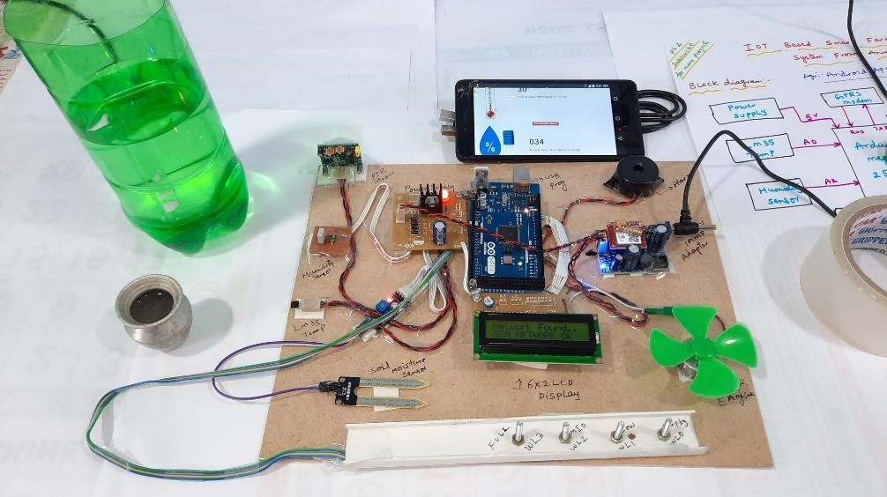

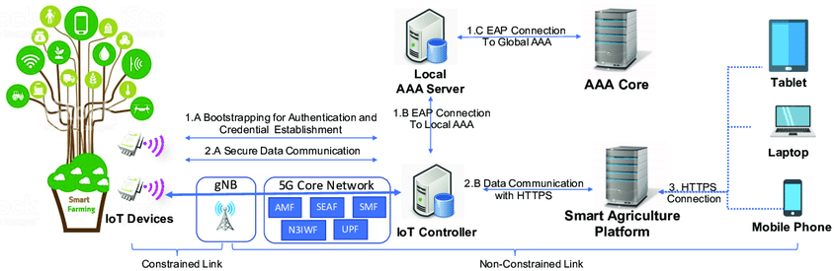

Low productivity of crops is one of the main problems faced by the farmers in our country. This can be because of two main reasons. Crops destroyed by wild animals and because of bad weather condition.The system will provide a complete technical solution using the Internet of things (IOT) to the farmers to prevent their crops from wild animals and provide information to the farmers to maximize their production. Animals are detected using PIR sensors and cameras where animals are identified using TensorFlow image processing Techniques. Raspberry PI is used as the processing unit

of the system and sound buzzers are used to emit the ultrasound frequencies.

